**Capstone Proyect Report**

**The Battle of Neighborhoods**

**Introduction**

A REIT company wants to expands and diversify its business, they want to invest in venues in a new city, and they dont know anything about it. Making a preliminary analysis in order to identify potential business opportunities could increase future profit. With that objetive in mind, I am going to make a descriptive analysis of the venues of a city looking for unexploited markets. For example, a posible conclusion of the analysis would be: In post code 234911 of Mexico City Japanesse Restaurants of moderate price are almost non existant/ or with low rating.

**Data**

I will be using the Foursquare location data, the categories given, the rating, price tag, tips for making my analsys, a query using the Foursquare API of a concrete venue, could look something like this: 'primary': True}, {'id': '4bf58dd8d48988d110941735', 'name': 'Italian Restaurant', 'pluralName': 'Italian Restaurants', 'shortName': 'Italian', 'icon': {'prefix': 'https://ss3.4sqi.net/img/categories_v2/food/italian_', 'suffix': '.png'}}], 'verified': False, 'stats': {'tipCount': 56}, 'url': 'http://harrysitalian.com', 'price': {'tier': 2, 'message': 'Moderate', 'currency': '$'}, 'hasMenu': True, 'likes': {'count': 120, 'groups': [{'type': 'others', 'count': 120, 'items': []}], 'summary': '120 Likes'}, 'dislike': False, 'ok': False, 'rating': 6.9, ...

**Methodology**

I decided to start a exploratory analysis in the city on Madrid.

After the first contacts with the data I realize the limitation that comes with the free foursquare account. As I could only get a maximum of 50 results from a search query, I devised a simple method for working around that issue.

Instead of just one query, I made 4 with different centers and smaller radius to approximate the initial intended search area. I used the geopy module for measuring the distances and accommodated the radius until one of the queries got close to 50, this process is represented in the following image:

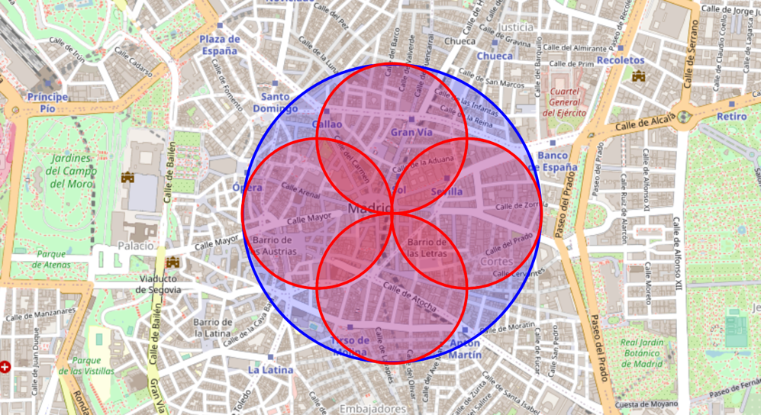

I explored the different kind of venues, and the ones with most data points where the ‘restaurant’ category venue. So I did a search query for the ‘restaurant’ category, and after cleansing the data (eliminating duplicates etc) I got the following data points for restaurants:

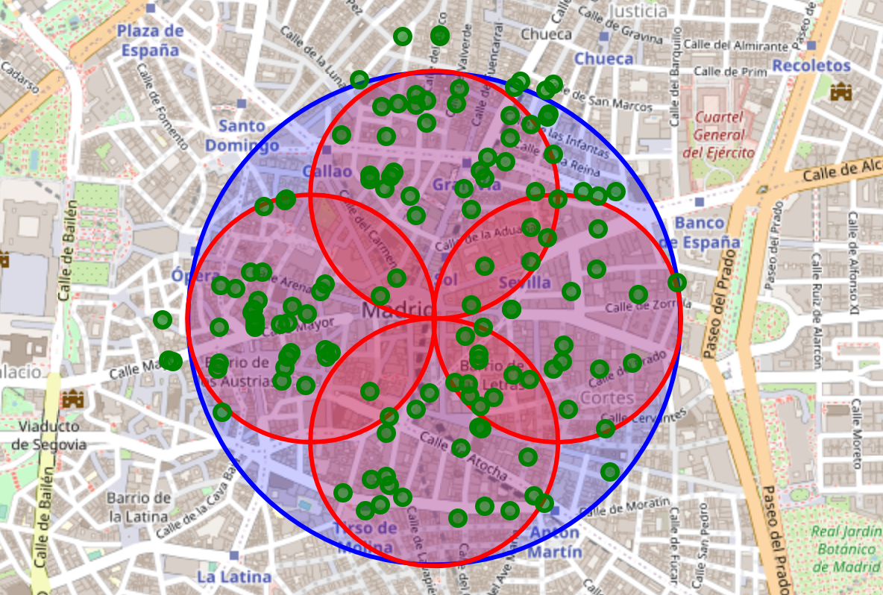

This are the top categories found:

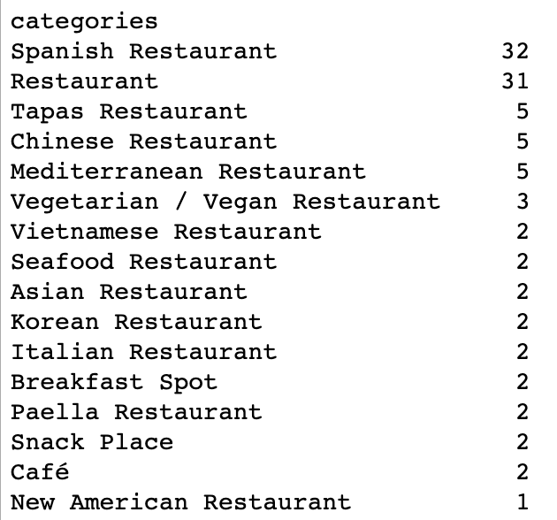

We can observe a prevalence of Spanish restaurants(as expected), also a lot of uncategorized data points( simply ‘Restaurant’).

For each restaurant I´m going to query it´s id to foursquare for gaining extra insight on the data. Specifically the ‘price tier’, ‘rating’ and ‘rating_signal’. The ‘price tier’ category was later ignored because more than 95% of the restaurants had the same value. And all restaurants with incomplete information was ignored, this problem could be solved with a premium foursquare account or similar, for the purposes of this exercise, we will assume that those data points are the only ones that exist.

The ‘rating_signal’ is the number of ratings that have been given to a given venue, this is relevant information, because it´s not the same a venue with a 10 rating with only 2 reviews, than one with 9,5 with 500 reviews. For taking this into account we create a new feature in the data ‘true rating’ which aggregates this 2 pieces of information.

This is the distribution on the new ratings:

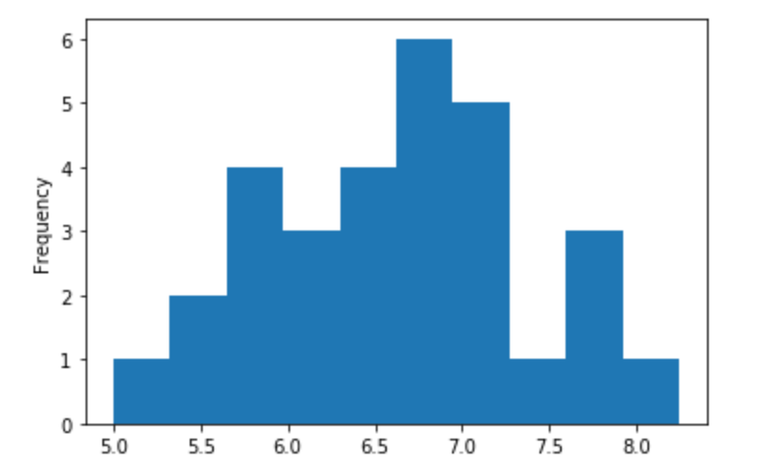

The next tables shows the data of the average rating for each category:

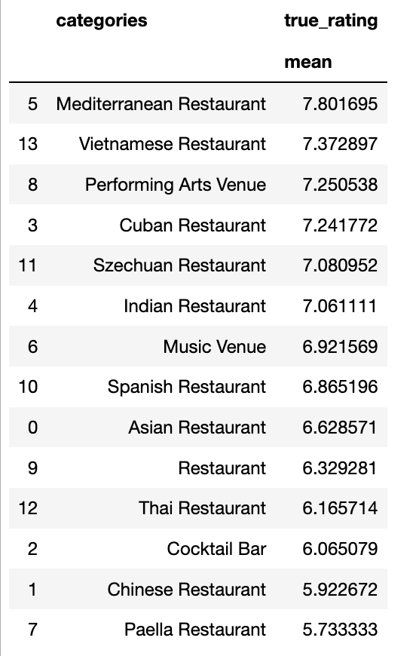

With this results we categorize each restaurant in ‘low’, ‘middle’, and ‘high’:

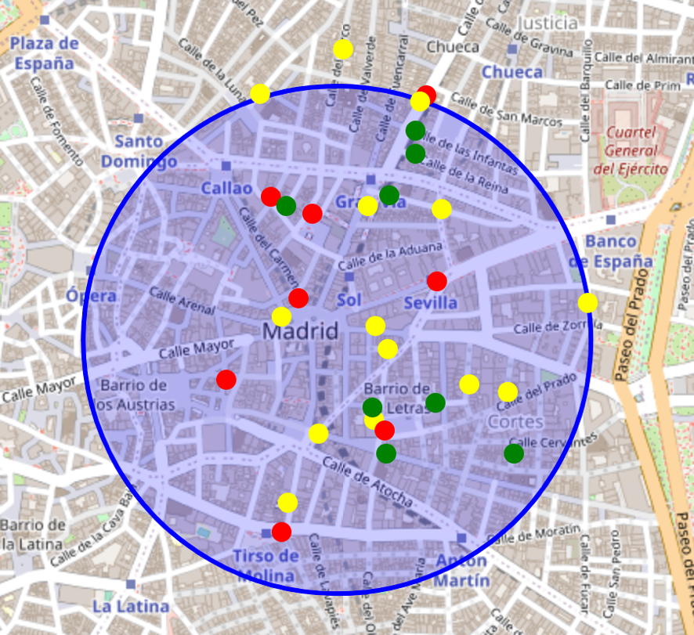

The color Red represents low rating, yellow middle and green a high rating.

Next I looked for isolated low rated points, as good candidates for buying(and remodeling) or for opening a new venue with good prospects.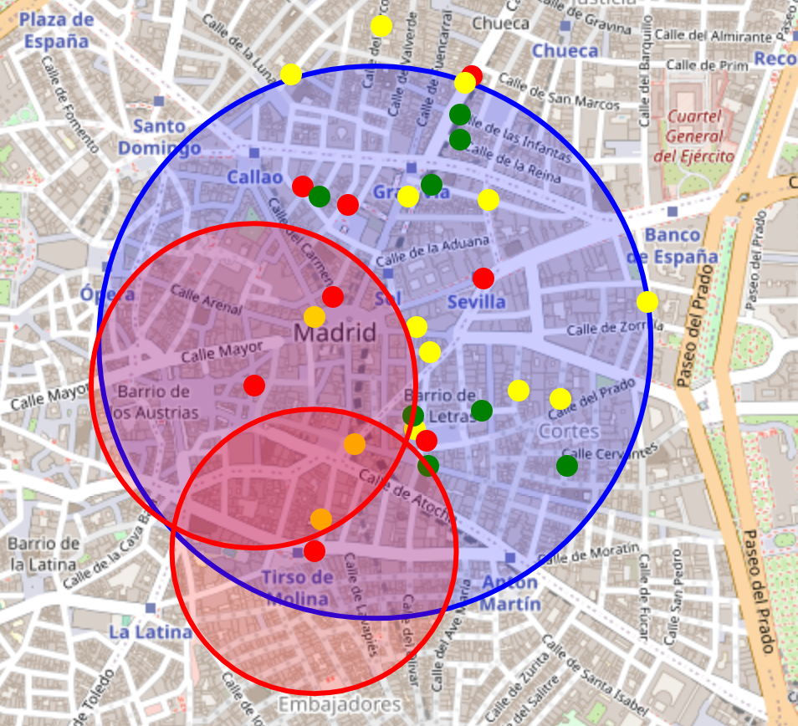

In this case 2 candidates stood out, with more than 300 meters distance to the closest high rated restaurant.

**Results**

The main results of the exploratory analysis are shown below:

Histogram of the true_ratings:



Average Rating grouped by categories:



Geographic representation of the low,average,high ratings:



The same visuals as before, but highlighting the 2 low rated points with higher distance to closest high rated restaurant:



**Discussion**

Firstly, given the true ratings grouped by categories we can observe that Chinese, Asian and Paella restaurants have very low average ratings, so there is a market opportunity for this categories to shine in the market without much competition.

Secondly, we can observe 2 venue locations that are situated very far from a high rated venue, which means even less competition for building a new one in that area.

With this information we can recommend that opening a Chinese, Asian or Paella Restaurant with high quality in this areas, would be a very interesting investing strategy because, as mentioned above, the is low market competition geographically and category wise.

**Conclusion**

The analysis conclusion is that we recommend the opening of a Chinese, Asian or Paella Restaurant with high quality in the west side of madrid city(specifically near the red dots shown in the map.